AR Pocket Trainer

## Final Year Project Proposal Session 2019-2023

A project submitted in partial fulfilment of the COMSATS University Degree

Of

BS in Software Engineering (CUI)



Department of Computer Science COMSATS University Islamabad, Attock Campus

04 March 2022

**Project Registration Form**

|  |  |  |  |  |  |  |  |
| --- | --- | --- | --- | --- | --- | --- | --- |
| Project ID (for office use) | | |  | | | | |
| Project Title | | | AR Pocket Trainer. | | | | |
| Type (Nature of project) | | | [ ] Desktop Application [ ] Web Application [**✓**]Mobile Application | | | | |
| Area of specialization | | | Machine learning, Augmented Reality, Artificial Intelligence, Computer Vision and cross Platform App (Android and ios). | | | | |
| **Project Group Members** | | | | | | | |
| Sr.# | Registration No | Student Name | | CGPA | Email ID | Contact No | Signature |
| 1. | FA19-BSE-034 | Malik Muneeb Shahid | | 3.54 | Fa19-bse- [034@cuiatk.edu.pk](mailto:034@cuiatk.edu.pk) | 0335-8383278 |  |
| 2. | FA19-BSE-032 | Junaid Ahmed | | 3.04 | Fa19-bse- [032@cuiatk.edu.pk](mailto:032@cuiatk.edu.pk) | 0321-6164794 |  |
| Name & Signature of Program Coordinator to certify that  Are the students eligible for FYP? [ ] Yes [ ] No | | | | |  | | |

## Consent and Plagiarism Certificate from Supervisor

I affirm to accept and supervise the above-mentioned students throughout the project duration. This is to certify that this FYP proposal is checked by me and the similarity index is % that is less than 19%, an acceptable limit by HEC. Report is attached herewith.

Name of Supervisor: Waqas Ahmad Co-Supervisor (if any): Yasir Ali Shah

Designation: Designation:

Signature:

**Approval of FYP Management Committee**

Signature:

Committee Member 1: Name:

[ ] Accept [ ] *Defer [ ] *Reject Signature:

*Remarks:

Committee Member 2: Name:

[ ] Accept [ ] *Defer [ ] *Reject Signature:

*Remarks:

Convener: Name:

[ ] Accept [ ] *Defer [ ] *Reject Signature:

*Remarks:

# Project Abstract

Working out on your own can be a struggle especially, if you are a beginner and don’t know where to start because there are tons of workout plans out there and each with a million exercises stacked for you to go through and that just makes you lose hope unless you hire a personal trainer who can help you get through the endless jungle called “fitness journey”. But, the problem is personal trainers are not so “pocket friendly” thereby to tackle this problem and to get you that pack of six, we are going to develop an AR (Augmented Reality) fitness app which will guide you along your journey to become fit and fine.

Our app will start off by calculating your BMI and analyzing your body structure (using Computer Vision) following which will be a diet plan provided to you either calorie deficit or calorie surplus once done with that you will then be directed to workout plan where our app will guide you throughout your workout using Augmented Reality and as you deal with that stuff our app will automatically be keeping track of your progress using Artificial Intelligence and real time body movements recognition and also provide you with analytics that will help you track your progress easily so that you can focus on one and only one goal (yep, you guessed it right) of getting fit.

# Introduction

“If you look good you feel good”

We all agree that fitness is important right? And to help us achieve it a lot of efforts have already been made, there are hundreds of apps available on the internet but what we have noticed is none of them is using augmented reality to guide the user. They are either a well- organized collection of fitness videos or a bunch of exercise plans, not denying the impact they have (technology always has anyway) but we are talking about doubling the magnitude of that impact by giving it a dip in Artificial Intelligence, Augmented Reality and Machine learning.

So, our user will start off by creating his/her account after which they will go through a short body physique inspection with the help of computer vision and for more accuracy we will use body BMI. So, then user will be provided with information of their current state and a matching diet plan after which they will be shown a few introductory videos about what fitness really means and a bit of motivation, phase one ends here. The next step is about bringing things to ground reality where our application will find a suitable workout plan for them, as the user is performing his exercise his body posture and steps will be monitored

and recorded, the app will notify him wherever he is doing a mistake and will not count that repetition. There will also be a weekly examination of his body and app will compare his current stats with the ones that were recorded on day one and tell him how much he has achieved since day one along with that he will also be provided with the weekly report of his workout so he can better analyze his track record.

# Motivation and Scope

Our primary motivation behind building of this project is to help those peoples who wants an effective workout and diet plan but didn’t afford professional trainer because of less resources. Helping these type of peoples using modern technology is our big motivation behind construction of this project.

# Related Work

Following are some apps on Google Play Store that provide some related functionalities:

## Workout Plan and Gym Log Tracker:

This app only provides you to make your workout plan without any suggestion and maintain your logs manually like how many reps you do of a particular exercise.

## Pro Fitness:

Users of this app are provided with the different exercises with a complete description of all exercises.

## 30 Day Fitness Challenge:

Provide 30 days workout plan to reduce to weight and also give a reminder message for exercise.

## 7 Minute Workout:

This app provide you to make a calendar for your daily exercises in addition to that user can manually start timer to note down the time of workout.

Table 1: Comparison Table

|  |  |  |  |  |  |
| --- | --- | --- | --- | --- | --- |
| **Functionalities** | **Proposed** | **Pro Fitness** | **Workout plan** | **30 Days fitness challenge** | **7 Minute workout** |
| AR Trainer | ✔ | ✖ | ✖ | ✖ | ✖ |
| Body Physique Recognition | ✔ | ✖ | ✖ | ✖ | ✖ |
| Workout Reminder | ✔ | ✖ | ✖ | ✔ | ✖ |
| Diet Plan | ✔ | ✖ | ✖ | ✖ | ✖ |
| Video Recommendations | ✔ | ✖ | ✖ | ✖ | ✖ |
| Progress tracker | ✔ | ✔ | ✖ | ✖ | ✔ |
| Weekly comparison | ✔ | ✖ | ✖ | ✖ | ✖ |
| Exercises | ✔ | ✔ | ✔ | ✔ | ✔ |

# System Architecture and Feature:

**Features:**

## Body Physique Recognition:

Using computer vision and machine learning techniques we will recognize physique of a user body through which we recommend type of diet and exercise needed to reshape your body.

## AR Trainer:

Our App will tell you the right way of doing exercise using augmented 3d model of a trainer on same environment in which you want to exercise.

## Progress Tracking:

Using computer vision and machine learning techniques we will record your daily workout.

## Diet plan suggestion:

Using BMI and body physique; app will suggest a healthy diet plan to its user.

## Video recommendation:

Suppose if a user didn’t understand an exercises through AR model then app will recommend a suitable video in addition to that app will also recommend a videos to motivate its users.

## Workout plan suggestion:

Using BMI and body physique; app will suggest suitable workout plan.

## Weekly comparison:

Using techniques of Data science our app will compare performance of a user weekly and at the end of every week it generate a report of its performance using attractive data visualization designs.

## Workout reminder:

App will generate a notification to remind its user that it is your workout time.

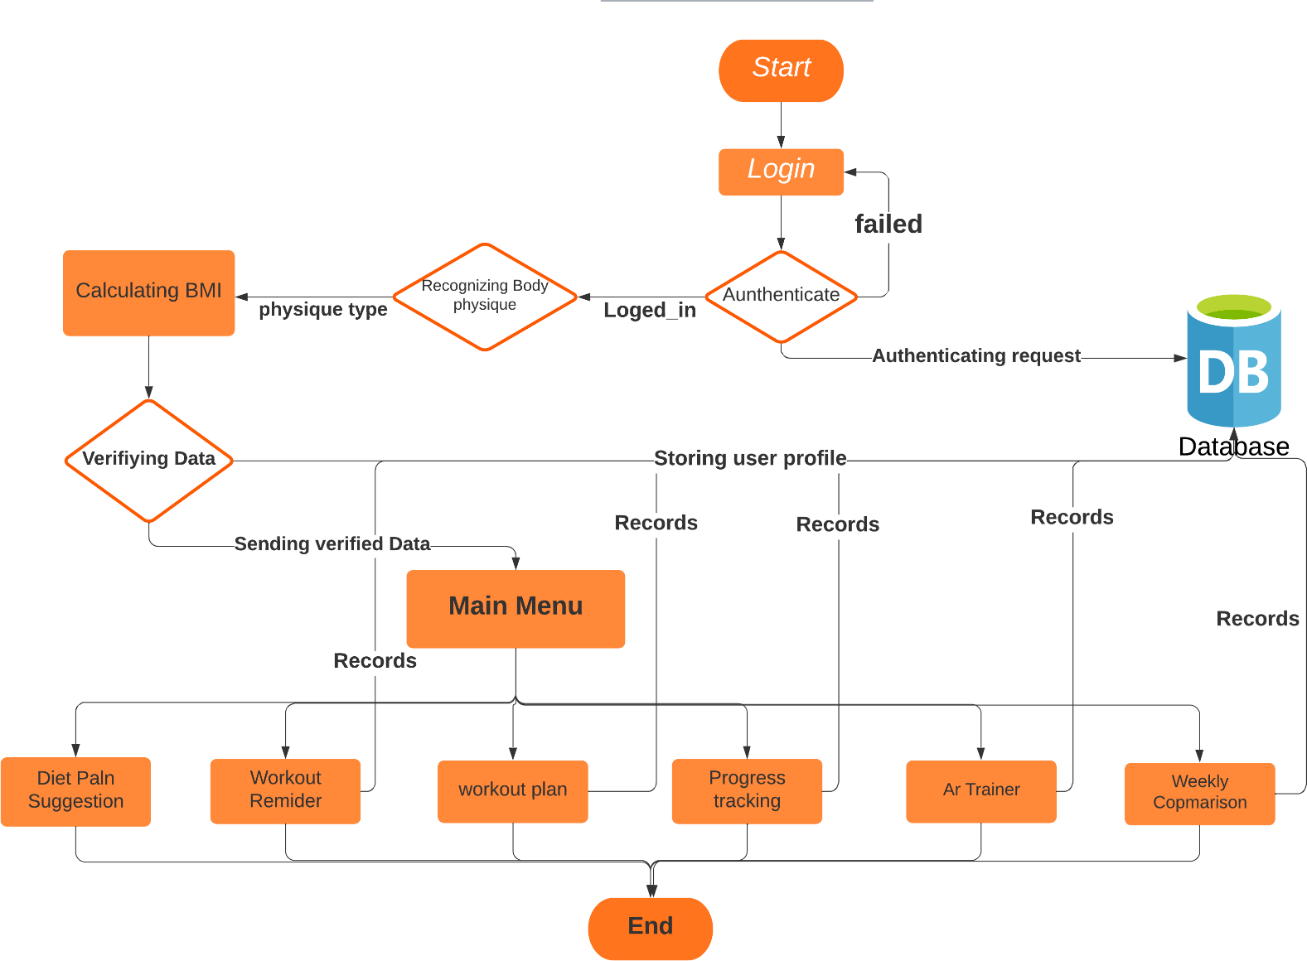

Figure 1: Flow Chart

# Goals and Objectives

* To create a fitness solution using power of computer vision and AI in order to help a user perform his workout in an efficient manner.
* To ease the process of weight gain/loss for user.
* To make working out easy and fun.
* To maximize the user's focus on his workout and diet routine by minimizing the effort in side tasks.
* To inspire users to become the best version of themselves.
* To provide a balanced diet to user.

# Individual Tasks

Table 2: Individual Tasks

|  |  |
| --- | --- |
| **Malik Muneeb Shahid** | **Junaid Ahmed** |
| * **Back-end Development**   Dataset  Model training  Augmented Model  Database  Other   * **Design**   Use Case Diagram  Class Diagram  Activity Diagram  Sequence Diagram  Timing Diagram  User Interface  Augmented 3d Model design   * **Testing**   Black Box Testing White Box Testing   * **Documentation** | * **Back-end Development**   Dataset  Database  Augmented Model   * **Front-end Development**   User Interface  Prototypes  Augmented 3d Model design  Other   * **Cross-platform App**   * Model integration   * **Documentation** * **Testing**   Static Testing  Black Box Testing |

# Gantt chart

All Activities tentative schedule.

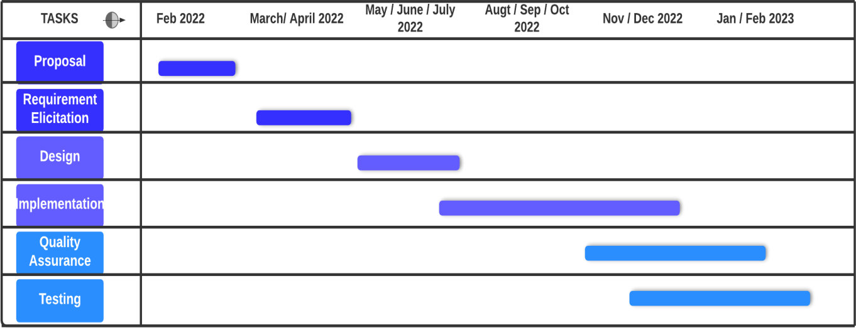

Figure 2: Gantt chart

**Tools and Technologies**

|  |  |
| --- | --- |
| **Tools** | Android Studio, IntelliJ Studio, Pycharm, Vuforia, Unity3d, Adobe After Effect. |
| **Languages** | Java, Kotlin, Python, Javascript, React Native. |
| **Libraries** | Skicit Learn, numpy, pandas, Open CV, Tensorflow. |